Session 1: Reflection Work Sheet
What Facilitating a Wedding, a Funeral, a Bat Mitzvah, and a Board Meeting Have in Common

What’s an especially positive gathering experience you
recall? (What was the event, where and when did it
take place, who came?)

What are a few specific factors that
contributed to this gathering’s success?
(What are some the bits that made it especially good?)
What was the result? (What was its impact on you or
others who gathered?)
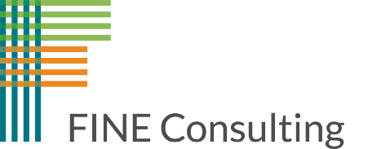

FINE Consulting www.fineconsultingllc.org melinda@fineconsultingllc.org 917-359-321

