The 5 Essential Elements of True Transformation
Element 3 – Purification & Detoxification
Letting Go for a Higher Purpose
Further Action Guide

Transformation Intention: _________________________________________

Following the ELSSAA method (Evaluate, Level, Strategize, Select, Action, Accountability) – a proven way to “un-freeze” or let go of what no longer serves you.

- Keeping in mind the transformation intention, survey your exploration writings/drawings, EVALUATE and circle all items identified to need purification of some type. (If this is your first workshop, make a list of things you are wanting to let go of in the interest of your highest good and desired transformation.)

- For each item that needs to be let go, rate it with a number from the detox complexity pyramid (1-5). This will assist with step 5 and goal setting because the goal needs to be at the same LEVEL as the complexity of the “detox”.

- Find a trusted detox partner(s) to brainstorm specific STRATEGY to let go of each identified item that is no longer serving you. This can be done in a small group. Write ideas here:

- From the brainstorm, SELECT the ideas that seem most in reach to support your path towards your custom-tailored detox. You can circle the above but then re write them in step 5 with SMART goals! (specific, measurable, achievable, relevant & timebound)

- Write at least 1 SMART goal per item to be let go in order to create your purification/detox ACTION plan.

- Make sure to identify a person or group to keep you ACCOUNTABLE to your deadlines and then follow up with the calendar dates you set.

My accountability partner is:
Contact info:

4 Helpful tricks:
1 - Use the google calendar system to predate deadlines

2 – Consider adding movement detox actions like spinal twists to also detox organs, weight bearing exercises to detox cells.

3 – Use supportive nutrition by eliminating inflammatory foods (sugar, preservatives, processed food, gluten, dairy. We are all unique, so we each have unique food intolerances.)

4 – Increase sleep hours while detoxing in any way. This will allow the body extra time to do its own restorative deep cleaning.

True Transformation Sequential Workshops
If a Ranch guest elects to do the 5 workshops sequentially, they will build each day on the day before to be poised and ready for the experience of a true transformation. Yet each individual workshop can stand alone to provide participants with new knowledge, an experiential process and clear homework “exercises” to deepen that element of inner fitness.

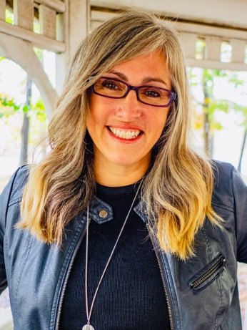
Dr. Julie Lopez Bio: Dr Julie’s relatable style inspires transformation of every type through her professional speaking, trainings and writings. She is the founder and CEO of Viva Partnership, a mental health inspired healing service offering virtual and in person coaching across 9 states. She is an award-winning entrepreneur and trauma expert, frequently sought by the media for her expertise in trauma, addictions and how to rework the “invisible” aspects of the human experience. Her book Live Empowered outlines the important role of Implicit Memory in true transformation.

